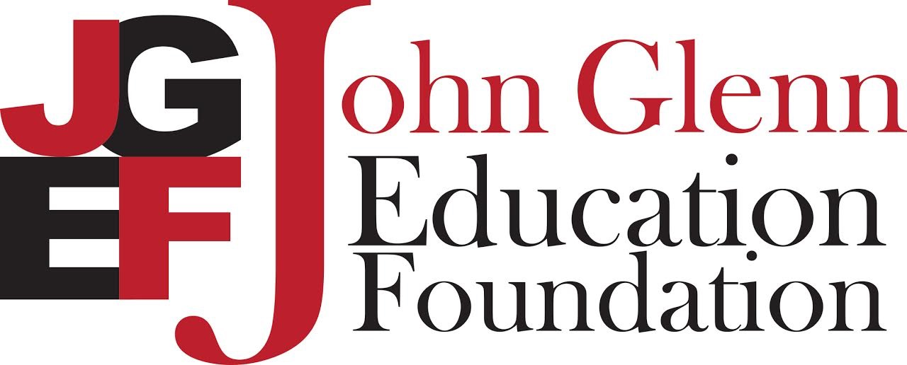

Parental Release Form

Mission: The John Glenn Education Foundation is dedicated, in partnership with our community, to promote and provide opportunities for our students and staff to learn and grow through enhanced educational experiences.

Vision: The vision of the John Glenn Education Foundation is to unite our community and provide opportunities for excellence in education for our students and staff through targeted investments in our school.

Purpose: To advocate, promote and fund initiatives to enrich learning experiences for students and staff of the John Glenn School Corporation. We work to bridge the gap between need and funding in two ways: through Innovative Teacher Grants and by funding educational programs and projects in the John Glenn School Corporation.

To achieve our mission, we have created documents and social media outlets to enhance awareness of our organization. We would like to be able to use photos of students within our corporation. Your son or daughter is shown in one or more of these photos. We would like to ask your permission to use the photo of your child.

I agree to let John Glenn Education Foundation (JGEF) use my child’s name or photo and/or give information to newspapers or other publications approved by JGEF or in connection with TV programs approved by JGEF or other media. I understand that I will not be paid for the use of my child’s photo. I understand that my child’s last name and street address will not be used in any media.

_____ I DO ALLOW JGEF to use my child’s photo in any media.

_____ I DO NOT ALLOW JGEF to use my child’s photo in any media.

_______________________________________ Print Name

_______________________________________ Signature

_______________________________________ Address, City

_______________________________________ Date

If you have any additional questions, please feel free to contact any of the following JGEF board members.

